Title: Font size 14, Times New Roman, left aligned, line spacing single, first letter should be capitalized, 24 pt before and after paragraph
Title of the study should be font size 14, Times New Roman, text aligned left, line spacing single, first letter capitalized, 24 pt before and after paragraph. Title should not exceed 15 words.

Authour(s) Name and Surname, 11 font size, left aligned, 10 pt before and after. Corresponding authour’s and other authours’ affiliation, country, e-mail, ORCID number should be inserted in footnote.∗∗
To cite this acticle:
Authour Surname, First letter of authour’s name. (2019). The title of the article, capitalize first letter. Journal Action Qualitative & Mixed Methods Research, Volume???(İssue???), ??-?? [Online] www.jaqmeronline.com DOI: ???
Abstract. Abstracts should contain 150-200 words. Abstract should include the purpose of the study, the type of mixed methods or action study designs, findings and results. Abstracts should be written using Times New Roman 9 font size. APA guidelines should be followed when writing the abstract. Abstracts should contain 150-200 words. Abstract should include the purpose of the study, the type of mixed methods or action study designs, findings and results. Abstracts should be written using Times New Roman 9 font size. APA guidelines should be followed when writing the abstract. Abstracts should contain 150-200 words. Abstract should include the purpose of the study, the type of mixed methods or action study designs, findings and results. Abstracts should be written using Times New Roman 9 font size. APA guidelines should be followed when writing the abstract. Abstracts should contain 150-200 words. Abstract should include the purpose of the study, the type of mixed methods or action study designs, findings and results. Abstracts should be written using Times New Roman 9 font size. APA guidelines should be followed when writing the abstract.
Keywords: Times New Roman, 9 font size, 3 – 7 words, first letter should be capitalized and should not exceed 7 words.

Introduction
(Introduction, font size Times New Roman 11, level 1 Heading, left aligned, first letter capitalized, 24 pt before paragraph and 10 pt after paragraph)
Introduction should include theoretical and conceptual framework, the aim and the importance of the study. Times New Roman, font size 11, 10 pt before and after paragraph. APA guidelines should be followed when citing in text and references. Quotation less than 40 words should be wtitten in text with quotation marks and reference page numbers, Quotation over 40 words should be started on a new line, indented 1 cm from the margin, 9 font size without quotation marks.
Quotation less than 40 words should be wtitten in text with quotation marks and reference page numbers, Quotation over 40 words should be started on a new line, indented 1 cm from the margin, 9 font size without quotation marks. Quotation less than 40 words should be wtitten in text with quotation marks and reference page numbers, Quotation over 40 words should be started on a new line, indented 1 cm from the margin, 9 font size without quotation marks. (JOMES, 2019, p.1).
The text of all sub-titles including introduction, method, findings, discussion and conclusion in all text should be written as Times New Roman, font size 11, 10 pt before and after paragraph.

Methodology
(Method, font size Times New Roman 11, level 1 Heading, left aligned, first letter capitalized, 24 pt before paragraph and 10 pt after paragraph)
Methodology should include research paradigm, design, sampling, data collection, data analysis, ethical considerations, validity and reliability. You should explain what knowledge constitutive interest -technical, hermeneutic and emancipatory-, paradigms - radical structuralist based on positivism, functionalist based on post-positivism, interpretive and radical humanist based on anti-positivism-, design, data collection, sampling methods and techniques to choose and why based on reference book suggestions of qualitative, mixed and action research methods so that the data you collected from the sampling should support your aim. You should explain why and what action, qualitative and mixed methods design/variant you choose and cite methodological references. You should explain what to do to support reliability and validity of the research for the design you choose for the study. You should write what steps to follow to conform to the Publication Ethics and Publication Malpractice Statement based on the Committee on Publication Ethics Code of Conduct Guidelines available at www.publicationethics.org.
Times New Roman, font size 11, 10 pt before and after paragraph. APA guidelines should be followed. Under method heading sub-titles including sampling, data collection, data analysis, ethical considerations, validity and reliability just like sapmling and data collection as follows should be written in order.

Sampling
(Level 2 Heading, font size 11, italic, left aligned, first letter capitalized, Times New Roman, 12 pt before paragraph and 10 pt after paragraph)

Times New Roman, font size 11, 10 pt before and after paragraph. APA guidelines should be followed in citing. Sub-titles including introduction, method, findings, discussion, conclusion in all text should be written in order.

Data collection
(Level 2 Heading, font size 11, italic, left aligned, first letter capitalized, Times New Roman, 12 pt before paragraph 10 pt after paragraph)

Times New Roman, font size 11, 10 pt before and after paragraph. APA guidelines should be followed in citing. Times New Roman, font size 11, 10 pt before and after paragraph. APA guidelines should be followed in citing.

Ethics statement
(Level 2 Heading, font size 11, italic, left aligned, first letter capitalized, Times New Roman, 12 pt before paragraph 10 pt after paragraph)

Times New Roman, font size 11, 10 pt before and after paragraph. APA guidelines should be followed in citing. Times New Roman, font size 11, 10 pt before and after paragraph. APA guidelines should be followed in citing.

Rigour
(Level 2 Heading, font size 11, italic, left aligned, first letter capitalized, Times New Roman, 12 pt before paragraph 10 pt after paragraph)

Times New Roman, font size 11, 10 pt before and after paragraph. APA guidelines should be followed in citing. Times New Roman, font size 11, 10 pt before and after paragraph. APA guidelines should be followed in citing.

Data analysis
(Level 2 Heading, font size 11, italic, left aligned, first letter capitalized, Times New Roman, 12 pt before paragraph 10 pt after paragraph)

Times New Roman, font size 11, 10 pt before and after paragraph. APA guidelines should be followed in citing. Times New Roman, font size 11, 10 pt before and after paragraph. APA guidelines should be followed in citing.

Findings
(Findings, font size Times New Roman 11 , Level 1 Heading, left aligned, first letter capitalized, 24 pt before paragraph and 10 pt after paragraph)
Findings based on quantitative and qualitative data should be written taking interaction, timing, priority and mixing of qualitative and quantitative data into consideration. 11 font sized, Times New Roman, single spaced, 10 pt before paragraph after paragraph. APA guidelines should be followed in citing. The figure number and caption should be typed below the illustration in 10 font sized, left aligned, be numbered with Arabic numerals (1,2,3,….), 10pt before and after figure caption, “Figure 1” as bold and italic. Figures should be clear, embedded into the text and not supplied separately.
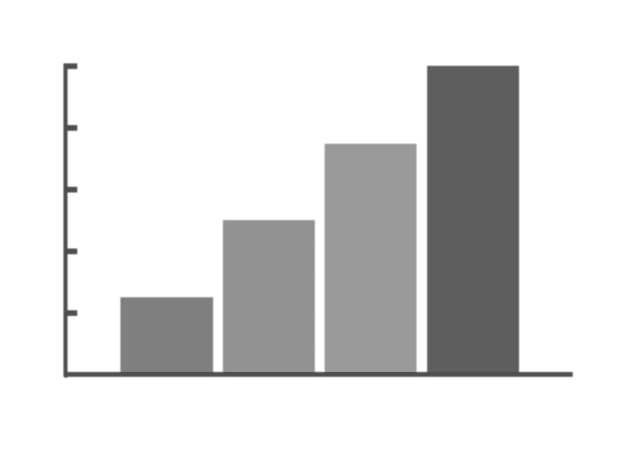
Figure 1. , First letter capitalized, Times new roman, 10 font sized
The table number and caption should be typed above the table in 10 font sized, italic, left aligned, be numbered with Arabic numerals (1,2,3,….), 10pt before and after table number and caption, “Table 1.” as bold. APA guidelines should be followed with tables. The text in table should be 10 font size.
Table 1.
The caption should be typed above the table in 10 font sized, italic, first letter capitalized
Theme | Sub-theme
The text in table should be 10 font size. | The text in table should be 10 font size.
The text in table should be 10 font size. | The text in table should be 10 font size.
The text in table should be 10 font size. | The text in table should be 10 font size.

Discussion
(Level 1 Heading, Times New Roman 11. font size 11, centered, first letter capitalized, 24 pt before the paragraph and 10 pt after paragraph)
You should decide what findings to take priority and discuss analytically by focusing on what findings really contribute to the phenomena of your research in the studies done so far and what are the similarities and difference between your research and studies done so far and what is known a new as a result of the research findings that was not known before so that you can contribute to relevant research literature. Times New Roman, font size 11, single line spacing, 10 pt before and after paragraph. APA guidelines should be followed when citing in text and references.
Conclusion
(Level 1 Heading, font size Times New Roman 11, centered, first letter capitalized, 24 pt before the paragraph and 10 pt after paragraph)
You should decide what significant conclusion to write focusing on significant conclusion consistent with your findings. Times New Roman, font size 11, single line spacing, 10 pt before and after paragraph.

Recommendations
(Level 2 Heading, left aligned, italic, first letter capitalized, Times New Roman 11, 12 pt before paragraph and 10 pt after paragraph)
You should decide what recommendations to put forward both for practitioners and researchers by suggesting attractive and innovative recommendations consistent with your findings. Times New Roman, font size 11, single line spacing and 10 pt before and after paragraph.

Acknowledgements
(Level 2 Heading, left aligned, italic, first letter capitalized, Times New Roman 11, 12 pt before paragraph 10 pt after paragraph)

Acknowledgements should be Times New Roman, font size 11, single line spacing, 10 pt before and after paragraph and without number. Text below continues as normal.

References
(Level 1 Heading, left aligned, Times New Roman 11, first letter capitalized, 24 pt before and paragraph 10 pt after paragraph)
APA guidelines should be followed when writing references, font size 10, left aligned, 6 pt before and after each reference. The second line and the rest should be indented 1,25 cm from the margin in the references more than two or more lines.
Authour Surname, First letter of author’s name. (2019). The title of the article, capitalize first letter. Journal of Mixed Methods Studies, Volume???(İssue???), ??-?? [Online] www.jaqmeronline.com DOI: ???
Appendix
(Level 2 Heading, left aligned, italic, first letter capitalized, Times New Roman 11, 12 pt before paragraph 10 pt after paragraph)

Authors including an appendix section should do so after References section. Multiple appendices should all have headings in the style used below, 11 font size, italic, left aligned and first letter capitalized. They will be ordered Appendix 1, Appendix 2 etc.
Appendix 1: Example of a sub-heading within an appendix.

(If necessary) Information about the article should be writted here as 9 font size, left aligned.
∗∗ Authour’s affiliation, country, e-mail, ORCID number: 9 font size, left aligned.

